**Index Page**

|  |  |  |  |
| --- | --- | --- | --- |
| **Practical No.** | **Practical Name** | **Date** | **Sign** |
| **1.** | **Creating Android Virtual device and Helloworld Program.** |  |  |
| **2.** | **Adding Android Resources (Color, Theme, String, Drawable, Dimension, Image).** |  |  |
| **3A.** | **Adding Multiple Activities and Fragments.** |  |  |
| **3B.** | **Text Passing with Intent.** |  |  |
| **4.** | **Working with Different Layouts.** |  |  |
| **5.** | **Alert Box** |  |  |
| **6.** | **Programming Menus, Dialog.** |  |  |
| **7.** | **Progress Bar.** |  |  |
| **8A.** | **Explicit Intent** |  |  |
| **8B.** | **Permission.** |  |  |

**PRACTICAL:1**

**AIM:** Introduction to Android, Introduction to Android Studio IDE, Creating a Project, Creating Android Virtual device, Android Application Overview. Simple “Hello World” program.

**SOURCE CODE:**

**Helloworld Program:**

Launch your android studio, click on File>>New>>New Project,

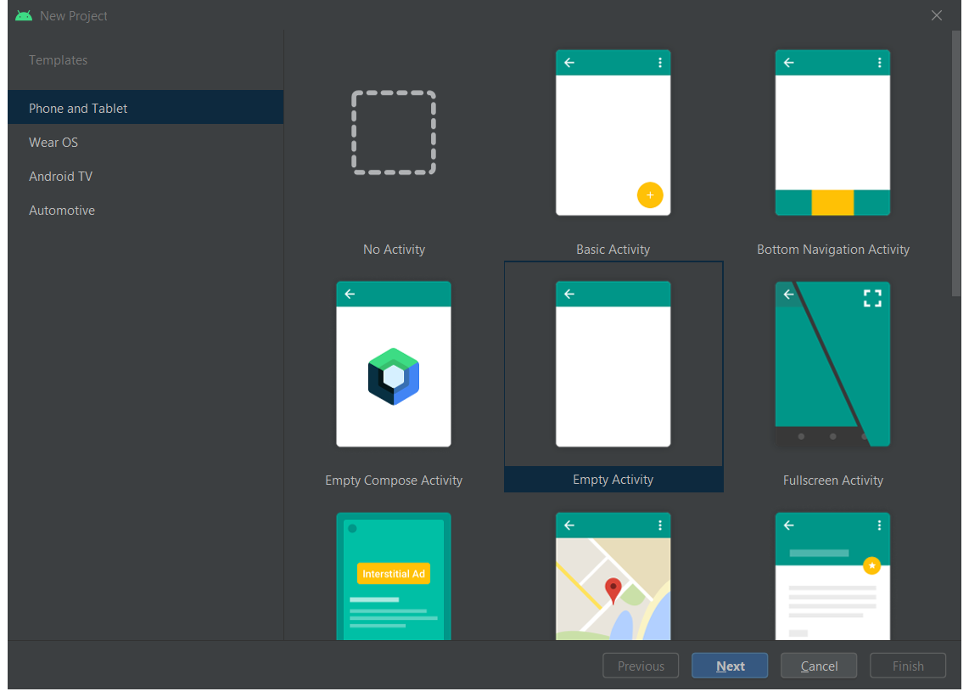

Select Empty Activity and then next,

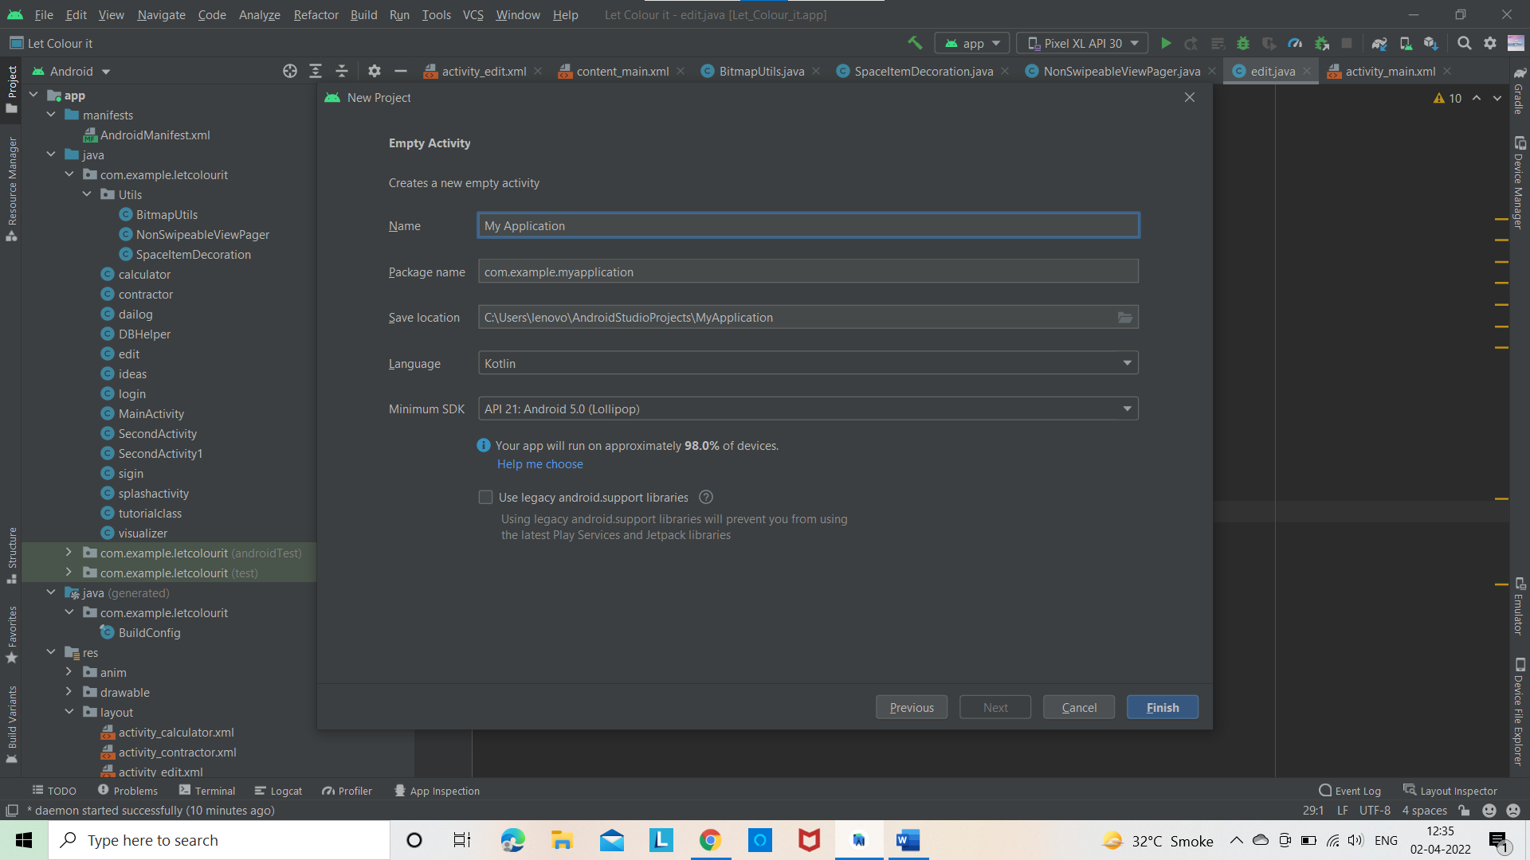

Provide your Application name and select language as koltin and then click on finish.

After few minutes your project will be ready.

MainActivity.kt:

package com.example.myapplication  
  
import androidx.appcompat.app.AppCompatActivity  
import android.os.Bundle  
  
class MainActivity : AppCompatActivity() {  
 override fun onCreate(savedInstanceState: Bundle?) {  
 super.onCreate(savedInstanceState)  
 setContentView(R.layout.*activity_main*)  
 }  
}

MainActivity.xml:

<?xml version="1.0" encoding="utf-8"?>  
<androidx.constraintlayout.widget.ConstraintLayout xmlns:android="http://schemas.android.com/apk/res/android"  
 xmlns:app="http://schemas.android.com/apk/res-auto"  
 xmlns:tools="http://schemas.android.com/tools"  
 android:layout_width="match_parent"  
 android:layout_height="match_parent"  
 tools:context=".MainActivity">  
  
 <TextView  
 android:layout_width="wrap_content"  
 android:layout_height="wrap_content"  
 android:text="Hello World!"  
 app:layout_constraintBottom_toBottomOf="parent"  
 app:layout_constraintLeft_toLeftOf="parent"  
 app:layout_constraintRight_toRightOf="parent"  
 app:layout_constraintTop_toTopOf="parent" />  
  
</androidx.constraintlayout.widget.ConstraintLayout>

**Output:**

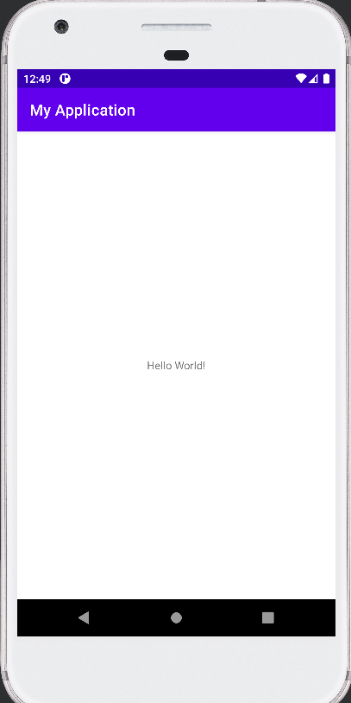

**Creating Android Virtual device:**

To open Device Manager:

Click on tools>>DeviceManager

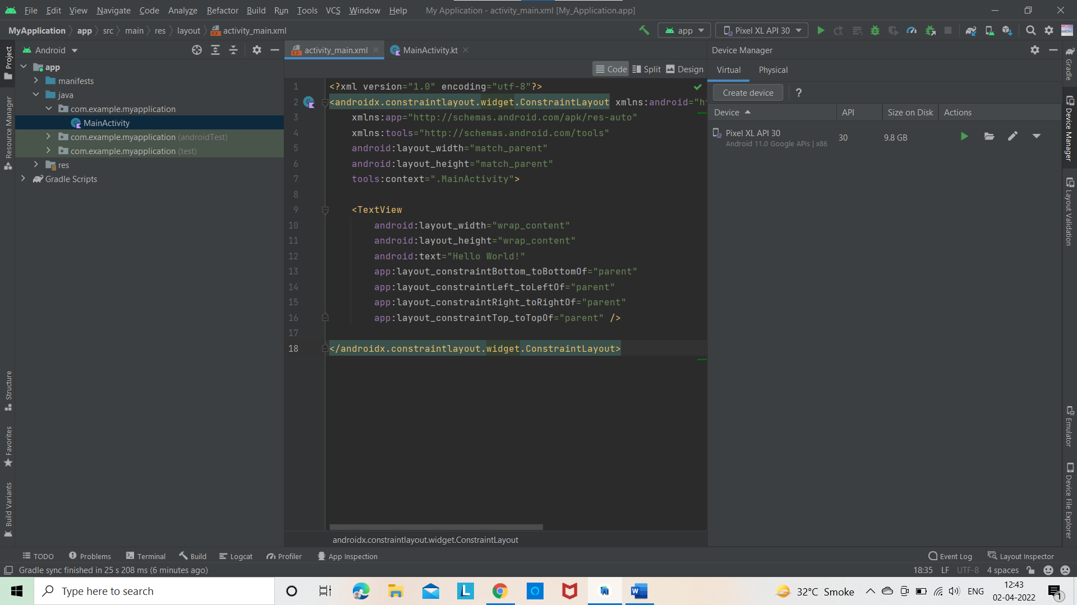

Click on Create virtual device>>Phone>>Pixel>>Next

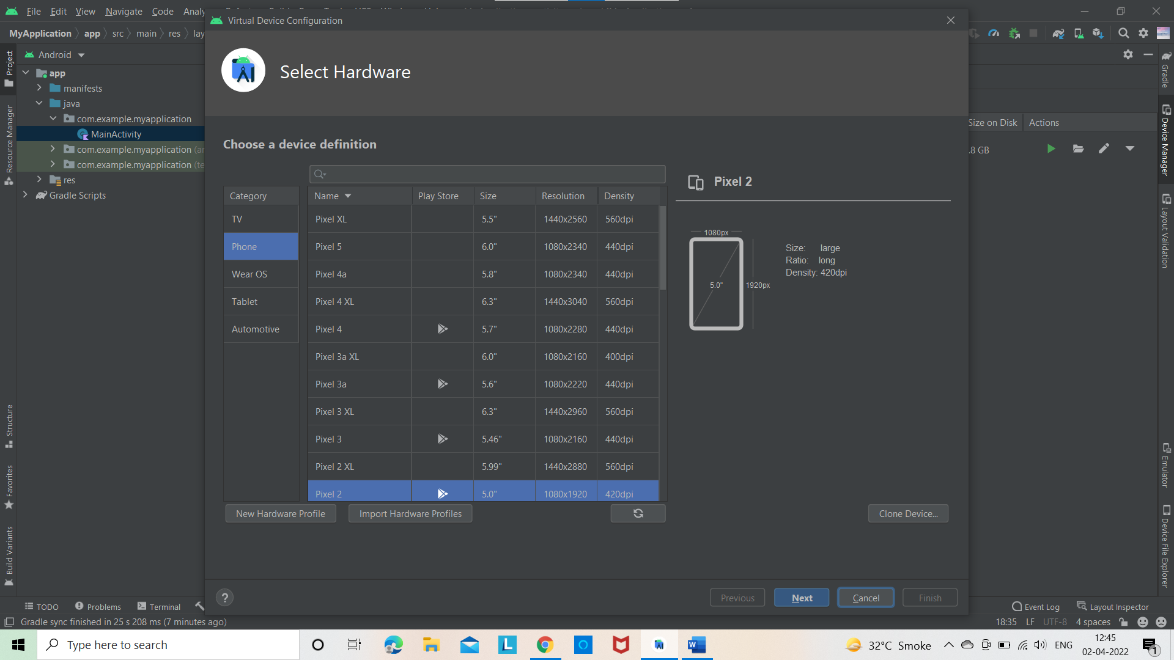

Select S And download it.Accept the terms and condition and start downloading.

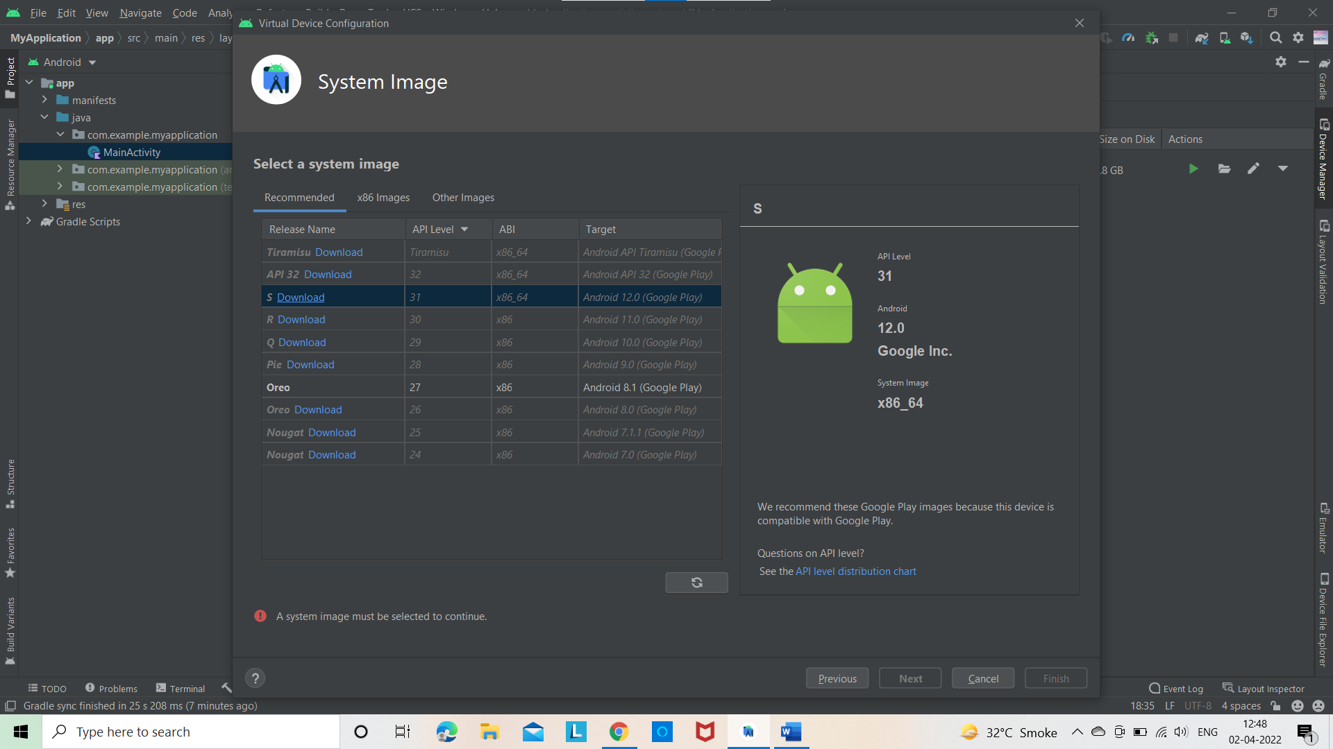

After downloading click on finish your virtual device is created.

**PRACTICAL:2**

**AIM:** Android Resources: (Color, Theme, String, Drawable, Dimension, Image).

**SOURCE CODE:**

**Colour:**

Launch your android studio and create new project. Under Android select res and under res select values and under values select colors.xml.

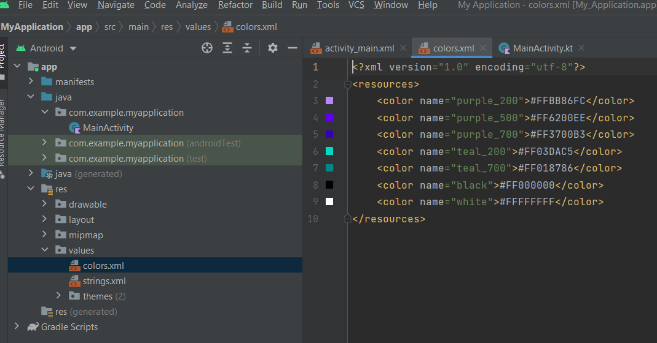

Add you color in colors.xml.

Color.xml:

<?xml version="1.0" encoding="utf-8"?>  
<resources>

<color name ="RED">#C61B1B</color>  
</resources>

**String:**

Launch your android studio and create new project. Under Android select res and under res select values and under values select strings.xml.

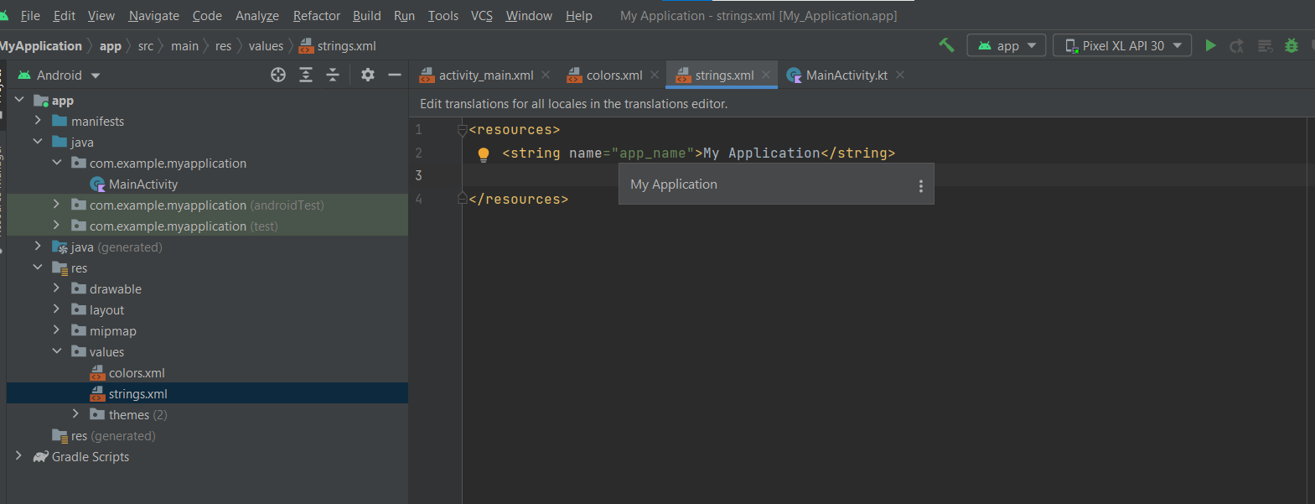

Add you color in strings.xml.

Strings.xml:

<resources>  
 <string name="app_name">My Application</string>  
 <string name="My_String">  
 <item>1</item>  
 <item>2</item>  
 <item>3</item>  
 </string>  
</resources>

**Drawable:**

1. Right click on drawable folder

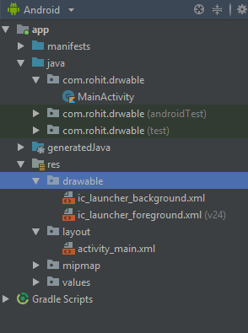

1. Copy the image if you want to create image drawable
2. Paste that image file inside the drawable folder

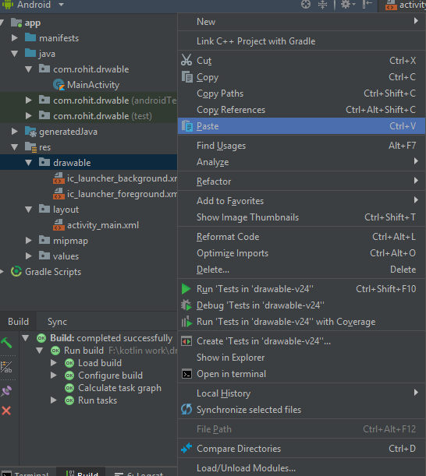

**Note: to create drawable resource, right click on drawable folder and select drawable resource file.**

Dimension,Image:

MainActivity.kt:

package com.example.myapplication  
  
import androidx.appcompat.app.AppCompatActivity  
import android.os.Bundle  
  
class MainActivity : AppCompatActivity() {  
 override fun onCreate(savedInstanceState: Bundle?) {  
 super.onCreate(savedInstanceState)  
 setContentView(R.layout.*activity_main*)  
 }  
}

MainActivity.xml:

<?xml version="1.0" encoding="utf-8"?>  
<androidx.constraintlayout.widget.ConstraintLayout xmlns:android="http://schemas.android.com/apk/res/android"  
 xmlns:app="http://schemas.android.com/apk/res-auto"  
 xmlns:tools="http://schemas.android.com/tools"  
 android:background="@drawable/nature"  
 android:layout_width="match_parent"  
 android:layout_height="match_parent"  
 tools:context=".MainActivity">  
  
 <TextView  
 android:layout_width="wrap_content"  
 android:layout_height="wrap_content"  
 android:text="Hello World!"  
 android:textColor="@color/RED"  
 app:layout_constraintBottom_toBottomOf="parent"  
 app:layout_constraintLeft_toLeftOf="parent"  
 app:layout_constraintRight_toRightOf="parent"  
 app:layout_constraintTop_toTopOf="parent" />  
  
 <TextView  
 android:layout_width="wrap_content"  
 android:layout_height="wrap_content"  
 android:layout_marginStart="16dp"  
 android:layout_marginTop="250dp"  
 android:layout_marginEnd="16dp"  
 android:text="@string/My_String"  
 android:textColor="@color/RED"  
 app:layout_constraintEnd_toEndOf="parent"  
 app:layout_constraintStart_toStartOf="parent"  
 app:layout_constraintTop_toTopOf="parent">  
  
 </TextView>  
  
</androidx.constraintlayout.widget.ConstraintLayout>

**Output:**

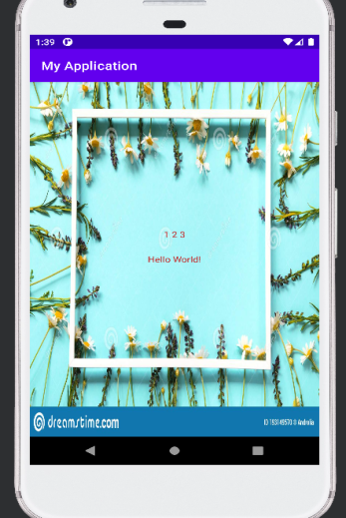

**PRACTICAL:3(A)**

**AIM:** Multiple Activities

**SOURCE CODE:**

MainActivity.kt:

package com.example.practicalone  
  
import android.content.Intent  
import androidx.appcompat.app.AppCompatActivity  
import android.os.Bundle  
import android.widget.Button  
  
  
class MainActivity : AppCompatActivity() {  
 override fun onCreate(savedInstanceState: Bundle?) {  
 super.onCreate(savedInstanceState)  
 setContentView(R.layout.*activity_main*)  
 val first_page = findViewById<Button>(R.id.*second_page*);  
 first_page.setOnClickListener**{** val intent = Intent(this,first_activity::class.*java*)  
 startActivity(intent)  
 **}** val second_page = findViewById<Button>(R.id.*third_page*);  
 second_page.setOnClickListener**{** val intent = Intent(this,second_activity::class.*java*)  
 startActivity(intent)  
 **}** }  
}

Activity_main.xml:

<?xml version="1.0" encoding="utf-8"?>  
<LinearLayout xmlns:android="http://schemas.android.com/apk/res/android"  
 xmlns:app="http://schemas.android.com/apk/res-auto"  
 xmlns:tools="http://schemas.android.com/tools"  
 android:layout_width="match_parent"  
 android:layout_height="match_parent"  
 tools:context=".MainActivity"  
 android:orientation="vertical">  
 <ImageView  
 android:layout_width="200dp"  
 android:layout_height="200dp"  
 android:src="@drawable/idea_one"  
 android:layout_gravity="center"/>  
  
 <TextView  
 android:layout_width="wrap_content"  
 android:layout_height="wrap_content"  
 android:text="This is Home page....."  
 android:textSize="25dp"  
 android:layout_gravity="center_horizontal"  
 />  
<Button  
 android:layout_width="wrap_content"  
 android:layout_height="wrap_content"  
 android:id="@+id/second_page"  
 android:text="First Page"  
 android:layout_gravity="center_horizontal"  
 android:layout_marginTop="10dp"/>  
 <Button  
 android:layout_width="wrap_content"  
 android:layout_height="wrap_content"  
 android:id="@+id/third_page"  
 android:text="Second Page"  
 android:layout_gravity="center_horizontal"  
 android:layout_marginTop="10dp"/>  
  
</LinearLayout>

First_Activity.kt:

package com.example.practicalone  
  
import android.content.Intent  
import androidx.appcompat.app.AppCompatActivity  
import android.os.Bundle  
import android.widget.Button  
  
class first_activity : AppCompatActivity() {  
 override fun onCreate(savedInstanceState: Bundle?) {  
 super.onCreate(savedInstanceState)  
 setContentView(R.layout.*activity_first*)  
 val home_page = findViewById<Button>(R.id.*home_page*);  
 home_page.setOnClickListener**{** val intent = Intent(this,MainActivity::class.*java*)  
 startActivity(intent)  
 **}** val third_page = findViewById<Button>(R.id.*third_page*);  
 third_page.setOnClickListener**{** val intent = Intent(this,second_activity::class.*java*)  
 startActivity(intent)  
 **}** }  
}

Activity_First.xml:

<?xml version="1.0" encoding="utf-8"?>  
<LinearLayout xmlns:android="http://schemas.android.com/apk/res/android"  
 xmlns:app="http://schemas.android.com/apk/res-auto"  
 xmlns:tools="http://schemas.android.com/tools"  
 android:layout_width="match_parent"  
 android:layout_height="match_parent"  
 tools:context=".first_activity"  
 android:orientation="vertical"  
 android:padding="10dp">  
 <ImageView  
 android:layout_width="200dp"  
 android:layout_height="200dp"  
 android:src="@drawable/idea"  
 android:layout_gravity="center"/>  
  
 <TextView  
 android:layout_width="wrap_content"  
 android:layout_height="wrap_content"  
 android:text="This is First page....."  
 android:textSize="25dp"  
 android:layout_gravity="center_horizontal"  
 />  
 <Button  
 android:layout_width="wrap_content"  
 android:layout_height="wrap_content"  
 android:id="@+id/home_page"  
 android:text="Home Page"  
 android:layout_gravity="center_horizontal"  
 android:layout_marginTop="10dp"/>  
 <Button  
 android:layout_width="wrap_content"  
 android:layout_height="wrap_content"  
 android:id="@+id/third_page"  
 android:text="Third Page"  
 android:layout_gravity="center_horizontal"  
 android:layout_marginTop="10dp"/>  
  
</LinearLayout>

Second_Activity.kt:

package com.example.practicalone  
  
import android.content.Intent  
import androidx.appcompat.app.AppCompatActivity  
import android.os.Bundle  
import android.widget.Button  
  
class second_activity : AppCompatActivity() {  
 override fun onCreate(savedInstanceState: Bundle?) {  
 super.onCreate(savedInstanceState)  
 setContentView(R.layout.*activity_second*)  
 val home_page = findViewById<Button>(R.id.*home_page*);  
 home_page.setOnClickListener**{** val intent = Intent(this,MainActivity::class.*java*)  
 startActivity(intent)  
 **}** val first_page = findViewById<Button>(R.id.*first_page*);  
 first_page.setOnClickListener**{** val intent = Intent(this,first_activity::class.*java*)  
 startActivity(intent)  
 **}** }  
}

Activity_Second.xml:

<?xml version="1.0" encoding="utf-8"?>  
<LinearLayout xmlns:android="http://schemas.android.com/apk/res/android"  
 xmlns:app="http://schemas.android.com/apk/res-auto"  
 xmlns:tools="http://schemas.android.com/tools"  
 android:layout_width="match_parent"  
 android:layout_height="match_parent"  
 tools:context=".second_activity"  
 android:orientation="vertical"  
 android:padding="10dp">  
 <ImageView  
 android:layout_width="200dp"  
 android:layout_height="200dp"  
 android:src="@drawable/caliwall"  
 android:layout_gravity="center"/>  
  
 <TextView  
 android:layout_width="wrap_content"  
 android:layout_height="wrap_content"  
 android:text="This is Second page....."  
 android:textSize="25dp"  
 android:layout_gravity="center_horizontal"  
 />  
 <Button  
 android:layout_width="wrap_content"  
 android:layout_height="wrap_content"  
 android:id="@+id/home_page"  
 android:text="Home Page"  
 android:layout_gravity="center_horizontal"  
 android:layout_marginTop="10dp"/>  
 <Button  
 android:layout_width="wrap_content"  
 android:layout_height="wrap_content"  
 android:id="@+id/first_page"  
 android:text="First Page"  
 android:layout_gravity="center_horizontal"  
 android:layout_marginTop="10dp"/>  
  
  
</LinearLayout>

**OUTPUT:**

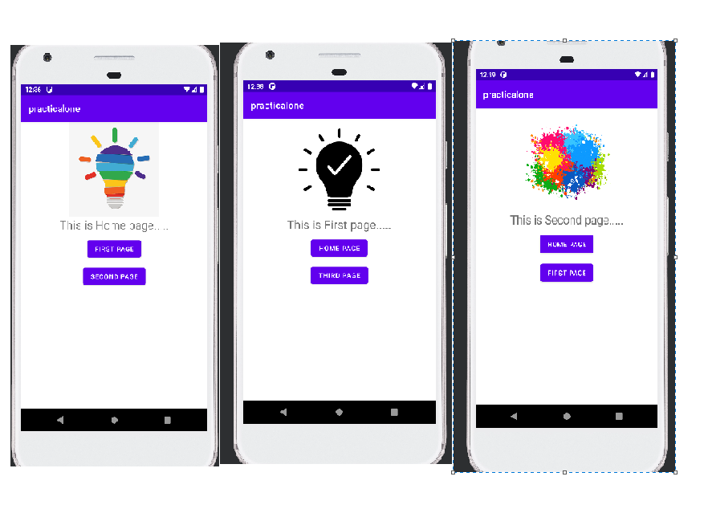

**PRACTICAL:3(B)**

**AIM: Text passing**

**SOURCE CODE:**

MainActivity.kt:

import android.content.Intent  
import androidx.appcompat.app.AppCompatActivity  
import android.os.Bundle  
import android.view.Menu  
import android.view.MenuItem  
import android.widget.Button  
import android.widget.EditText  
import android.widget.Toast  
  
  
class MainActivity : AppCompatActivity() {  
 override fun onCreate(savedInstanceState: Bundle?) {  
 super.onCreate(savedInstanceState)  
 setContentView(R.layout.*activity_main*)  
 val submit = findViewById<Button>(R.id.*Submit*)  
 submit.setOnClickListener**{** callActivity()  
 **}** }  
  
 private fun callActivity() {  
 val name = findViewById<EditText>(R.id.*name*)  
 val std = findViewById<EditText>(R.id.*Class*)  
 val Name = name.*text*.toString()  
 val Std = std.*text*.toString()  
 val intent = Intent(this,first_activity::class.*java*).*also* **{  
 it**.putExtra("NAME",Name)  
 **it**.putExtra("STD",Std)  
 startActivity(**it**)  
 **}** }  
  
  
}

activityMain.xml:

<?xml version="1.0" encoding="utf-8"?>  
<LinearLayout xmlns:android="http://schemas.android.com/apk/res/android"  
 xmlns:app="http://schemas.android.com/apk/res-auto"  
 xmlns:tools="http://schemas.android.com/tools"  
 android:layout_width="match_parent"  
 android:layout_height="match_parent"  
 tools:context=".MainActivity"  
 android:orientation="vertical">  
 <ImageView  
 android:layout_width="200dp"  
 android:layout_height="200dp"  
 android:src="@drawable/idea"  
 android:layout_gravity="center"/>  
  
 <TextView  
 android:layout_width="wrap_content"  
 android:layout_height="wrap_content"  
 android:text="This is Home page....."  
 android:textSize="25dp"  
 android:layout_gravity="center_horizontal"  
 />  
  
 <EditText  
 android:id="@+id/name"  
 android:layout_width="match_parent"  
 android:layout_height="wrap_content"  
 android:hint="Enter Name"  
 android:minHeight="48dp" />  
  
 <EditText  
 android:id="@+id/Class"  
 android:layout_width="match_parent"  
 android:layout_height="wrap_content"  
 android:hint="Enter Class"  
 android:minHeight="48dp" />  
 <Button  
 android:layout_width="wrap_content"  
 android:layout_height="wrap_content"  
 android:id="@+id/Submit"  
 android:layout_gravity="center_horizontal"  
 android:text="SUBMIT"/>  
  
  
</LinearLayout>

FirstActivity.kt:

package com.example.practicalone  
  
import android.content.Intent  
import androidx.appcompat.app.AppCompatActivity  
import android.os.Bundle  
import android.widget.Button  
import android.widget.TextView  
  
class first_activity : AppCompatActivity() {  
 override fun onCreate(savedInstanceState: Bundle?) {  
 super.onCreate(savedInstanceState)  
 setContentView(R.layout.*activity_first*)  
 val Name = *intent*.getStringExtra("NAME")  
 val Std = *intent*.getStringExtra("STD")  
 val txt1 = findViewById<TextView>(R.id.*text1*).*apply* **{** *text*=Name **}** val txt2 = findViewById<TextView>(R.id.*text2*).*apply* **{** *text*=Std **}** }  
}

activityFirst.xml:

<?xml version="1.0" encoding="utf-8"?>  
<LinearLayout xmlns:android="http://schemas.android.com/apk/res/android"  
 xmlns:app="http://schemas.android.com/apk/res-auto"  
 xmlns:tools="http://schemas.android.com/tools"  
 android:layout_width="match_parent"  
 android:layout_height="match_parent"  
 tools:context=".first_activity"  
 android:orientation="vertical"  
 android:padding="10dp">  
 <ImageView  
 android:layout_width="200dp"  
 android:layout_height="200dp"  
 android:src="@drawable/idea"  
 android:layout_gravity="center"/>  
  
 <TextView  
 android:layout_width="wrap_content"  
 android:layout_height="wrap_content"  
 android:text="This is First page....."  
 android:textSize="25dp"  
 android:layout_gravity="center_horizontal"  
 />  
 <TextView  
 android:layout_width="wrap_content"  
 android:layout_height="wrap_content"  
 android:id="@+id/text1"  
 android:textSize="25dp"  
 android:layout_gravity="center_horizontal"  
 />  
 <TextView  
 android:layout_width="wrap_content"  
 android:layout_height="wrap_content"  
 android:id="@+id/text2"  
 android:textSize="25dp"  
 android:layout_gravity="center_horizontal"  
 />  
  
  
</LinearLayout>

**Output:**

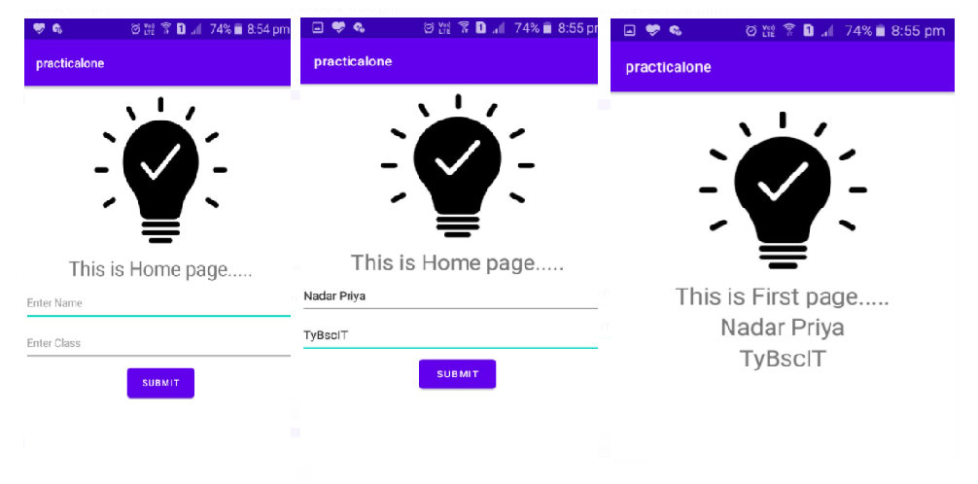

**PRACTICAL:4**

**AIM:** Programs related to different Layouts(Linear, Relative Layout)

**SOURCE CODE:**

Constraint Layout:

activityMain.xml:

<?xml version="1.0" encoding="utf-8"?>  
<androidx.constraintlayout.widget.ConstraintLayout xmlns:android="http://schemas.android.com/apk/res/android"  
 xmlns:app="http://schemas.android.com/apk/res-auto"  
 xmlns:tools="http://schemas.android.com/tools"  
 android:layout_width="match_parent"  
 android:layout_height="match_parent"  
 tools:context=".MainActivity">  
  
 <TextView  
 android:id="@+id/textView"  
 android:layout_width="wrap_content"  
 android:layout_height="wrap_content"  
 android:text="This is home page.........."  
 app:layout_constraintBottom_toBottomOf="parent"  
 app:layout_constraintLeft_toLeftOf="parent"  
 app:layout_constraintRight_toRightOf="parent"  
 app:layout_constraintTop_toTopOf="parent" />  
  
 <Button  
 android:layout_width="wrap_content"  
 android:layout_height="wrap_content"  
 android:layout_marginStart="8dp"  
 android:layout_marginTop="16dp"  
 android:layout_marginEnd="16dp"  
 android:layout_marginBottom="16dp"  
 android:text="Click here......."  
 android:textSize="10dp"  
 app:layout_constraintBottom_toBottomOf="parent"  
 app:layout_constraintEnd_toEndOf="parent"  
 app:layout_constraintHorizontal_bias="0.456"  
 app:layout_constraintStart_toStartOf="parent"  
 app:layout_constraintTop_toTopOf="parent"  
 app:layout_constraintVertical_bias="0.643" />  
  
 <ImageView  
 android:layout_width="200dp"  
 android:layout_height="200dp"  
 app:layout_constraintBottom_toTopOf="@+id/textView"  
 app:layout_constraintEnd_toEndOf="parent"  
 app:layout_constraintHorizontal_bias="0.497"  
 app:layout_constraintStart_toStartOf="parent"  
 app:layout_constraintTop_toTopOf="parent"  
 app:layout_constraintVertical_bias="0.544"  
 android:src="@drawable/home"/>  
  
</androidx.constraintlayout.widget.ConstraintLayou**t>**

**Output:**

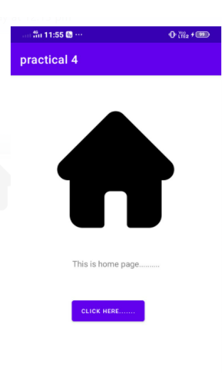

LinearLayout(Horizontal):

<?xml version="1.0" encoding="utf-8"?>  
<LinearLayout xmlns:android="http://schemas.android.com/apk/res/android"  
 xmlns:app="http://schemas.android.com/apk/res-auto"  
 xmlns:tools="http://schemas.android.com/tools"  
 android:layout_width="match_parent"  
 android:layout_height="match_parent"  
 tools:context=".MainActivity"  
 android:orientation="horizontal"  
 android:padding="10dp">  
 <ImageView  
 android:layout_width="100dp"  
 android:layout_height="100dp"  
 android:src="@drawable/home"/>  
 <ImageView  
 android:layout_width="100dp"  
 android:layout_height="100dp"  
 android:src="@drawable/idea_one"/>  
<TextView  
 android:layout_width="wrap_content"  
 android:layout_height="wrap_content"  
 android:text="AMP Journal"/>  
</LinearLayout>

**Output:**

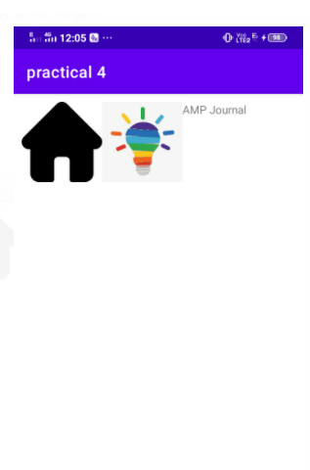

LinearLayout(Vertical):

<?xml version="1.0" encoding="utf-8"?>  
<LinearLayout xmlns:android="http://schemas.android.com/apk/res/android"  
 xmlns:app="http://schemas.android.com/apk/res-auto"  
 xmlns:tools="http://schemas.android.com/tools"  
 android:layout_width="match_parent"  
 android:layout_height="match_parent"  
 tools:context=".MainActivity"  
 android:orientation="vertical"  
 android:padding="10dp">  
 <ImageView  
 android:layout_width="100dp"  
 android:layout_height="100dp"  
 android:src="@drawable/home"/>  
 <ImageView  
 android:layout_width="100dp"  
 android:layout_height="100dp"  
 android:src="@drawable/idea_one"/>  
<TextView  
 android:layout_width="wrap_content"  
 android:layout_height="wrap_content"  
 android:text="AMP Journal"/>  
</LinearLayout>

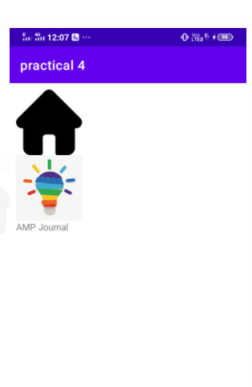**Output:**

**PRACTICAL:5**

**AIM: Alert Box**

**SOURCE CODE:**

MainActivity.kt:

override fun onBackPressed() {  
 super.onBackPressed()  
 val builder= AlertDialog.Builder(this)  
 builder.setTitle("Are you sure")  
 builder.setMessage("are you are sure to exist this app")  
 builder.setPositiveButton("YES",**{**dialogInterface,i**->** finish()**}**)  
 builder.setNegativeButton("NO",**{**dialogInterface,i**->}**)  
 builder.show()  
  
}

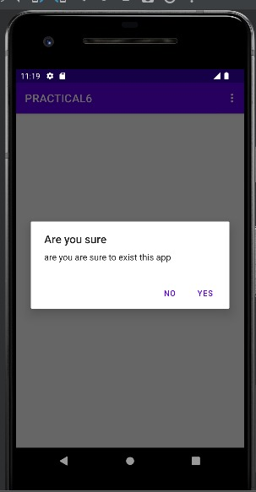**OUTPUT :**

**PRACTICAL:6**

**AIM:**  Programming menus, dialog

**SOURCE CODE:**

**Menu:**

**Under Android right click on app select new select android resource directory a new window will open like this**

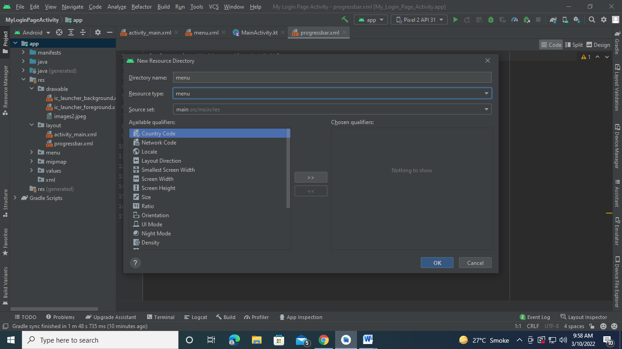

**Put menu for both directory name and resource type and then press ok.**

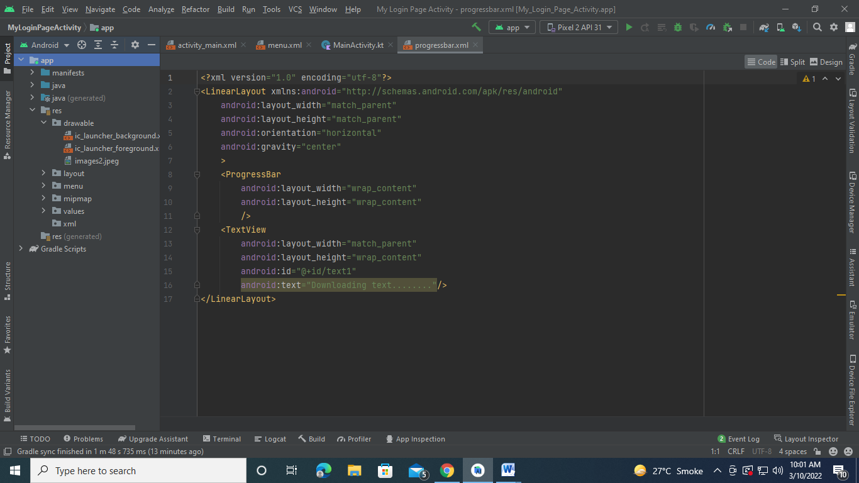

**After that under android menu will appear like above window right click on that**

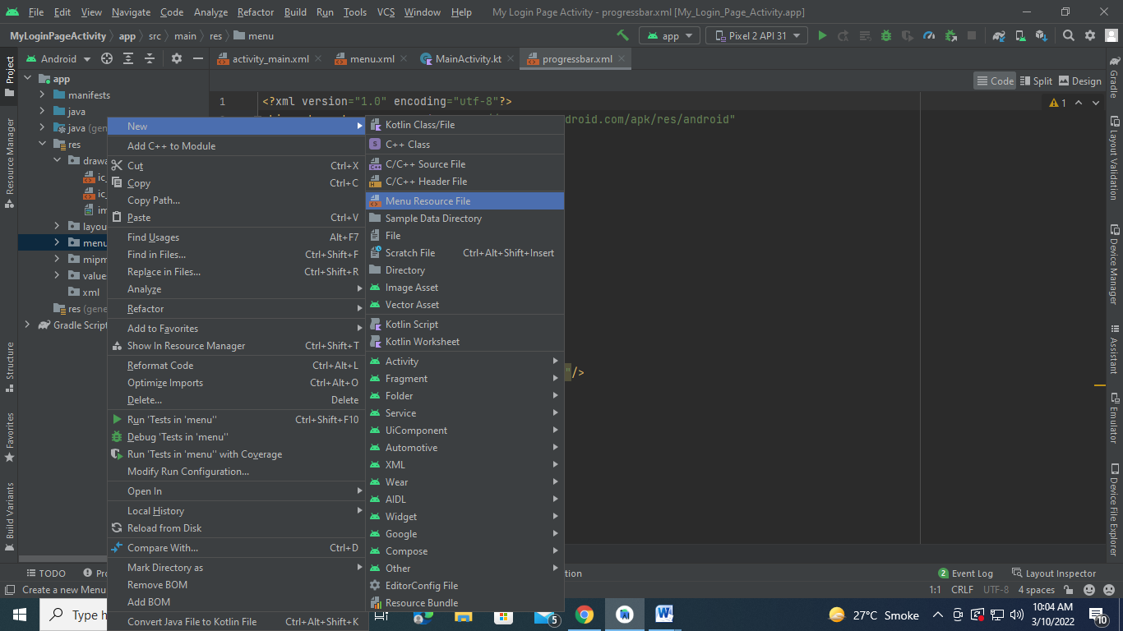

**Select menu resource file a new window will open like this**

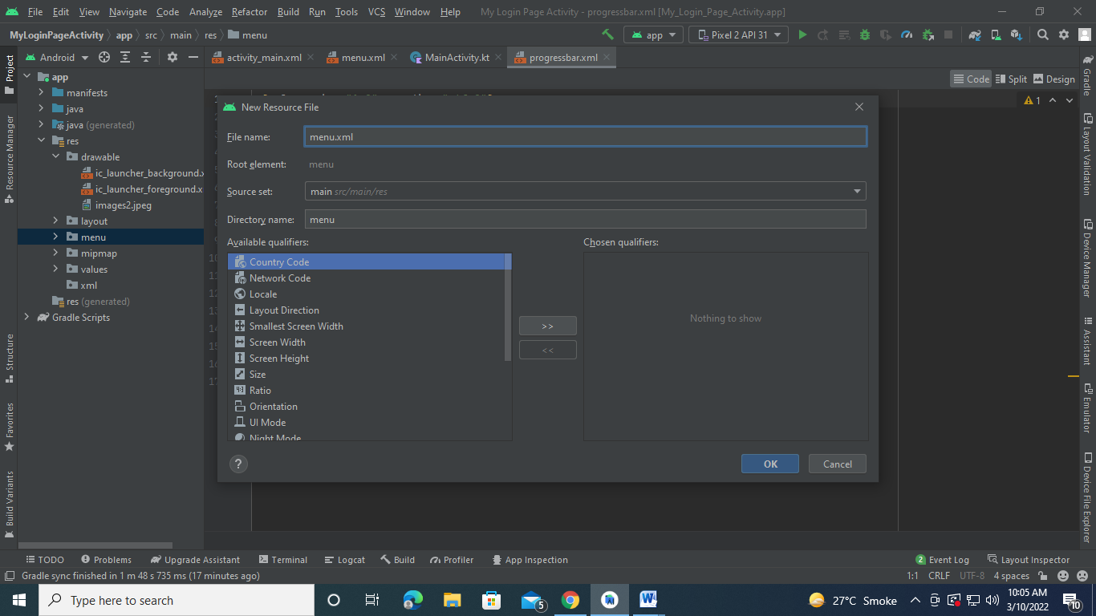

**Put file name as menu.xml and press ok**

Menu.xml:

<?xml version="1.0" encoding="utf-8"?>  
<menu xmlns:android="http://schemas.android.com/apk/res/android">  
<item  
 android:title="Contact us"  
 android:id="@+id/menu1"  
 />  
 <item  
 android:title="About us"  
 android:id="@+id/menu2"  
 /><item  
 android:title="Help"  
 android:id="@+id/menu3"  
 />  
</menu>

MainActivity.kt:

package com.example.myapplication  
  
import android.content.Intent  
import androidx.appcompat.app.AppCompatActivity  
import android.os.Bundle  
import android.view.Menu  
import android.view.MenuItem  
import android.widget.Toast  
  
class MainActivity : AppCompatActivity() {  
 override fun onCreate(savedInstanceState: Bundle?) {  
 super.onCreate(savedInstanceState)  
 setContentView(R.layout.*activity_main*)  
 }  
  
 override fun onCreateOptionsMenu(menu: Menu?): Boolean {  
 *menuInflater*.inflate(R.menu.*menu*,menu)  
 return super.onCreateOptionsMenu(menu)  
 }  
  
 override fun onOptionsItemSelected(item: MenuItem): Boolean {  
 var optionselected=""  
 when (item?.*itemId*){  
 R.id.*menu1* -> optionselected = "menu1 selected"  
 R.id.*menu2* -> optionselected = "menu2 selected"  
 R.id.*menu3* -> optionselected = "menu3 selected"  
  
 }  
 Toast.makeText(this,optionselected, Toast.*LENGTH_LONG*).show()  
  
 return super.onOptionsItemSelected(item)  
 }  
}

**Output:**

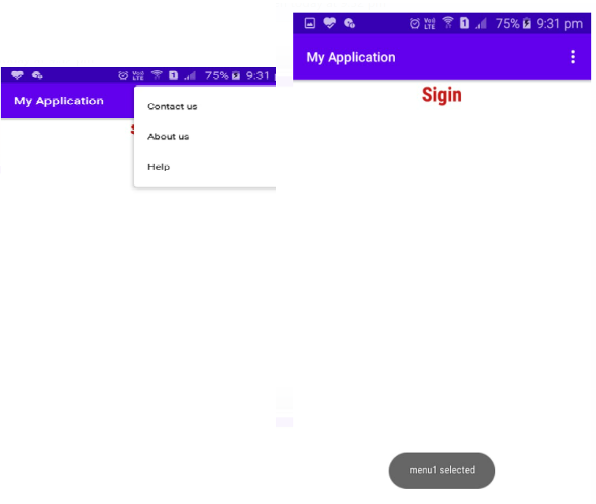

**PRACTICAL:7**

**AIM:**  Progress Bar

**SOURCE CODE:**

**Under Android right click on app select new select android resource file a new window will open like this, put file name as progressbar.xml and resource type as layout**

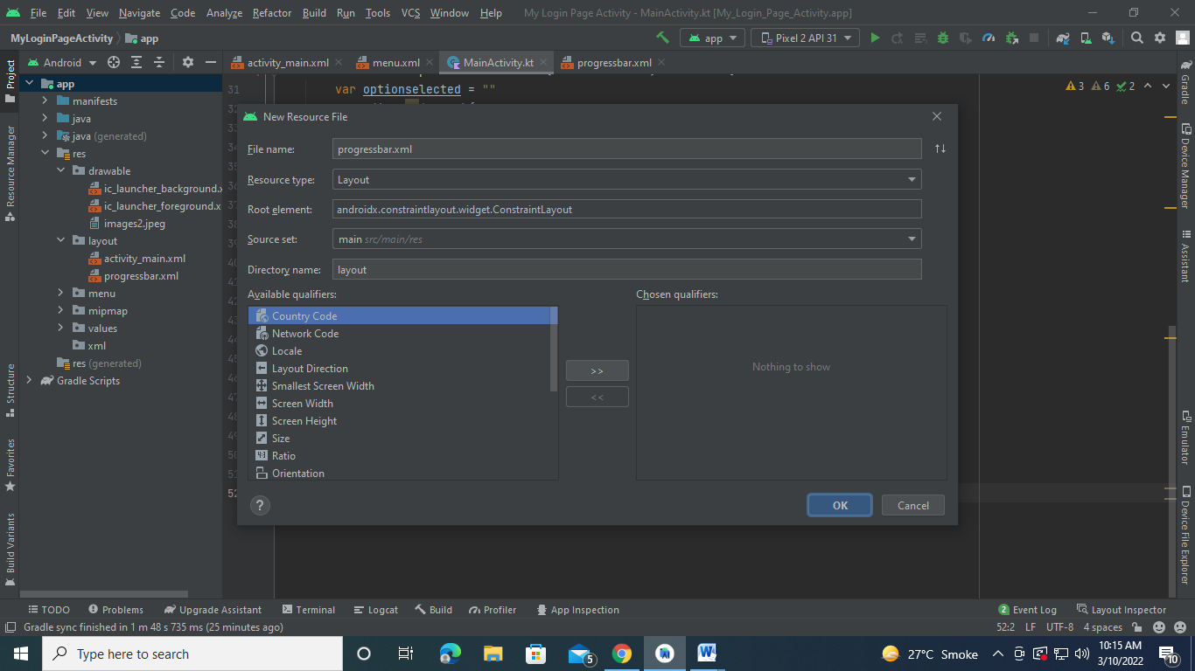 MainActivity.kt:

package com.example.myapplication  
  
import android.content.Intent  
import androidx.appcompat.app.AppCompatActivity  
import android.os.Bundle  
import android.view.Menu  
import android.view.MenuItem  
import android.widget.TextView  
import android.widget.Toast  
import androidx.appcompat.app.AlertDialog  
  
class MainActivity : AppCompatActivity() {  
 override fun onCreate(savedInstanceState: Bundle?) {  
 super.onCreate(savedInstanceState)  
 setContentView(R.layout.*activity_main*)  
 val builder=AlertDialog.Builder(this)  
 val dialogView = *layoutInflater*.inflate(R.layout.*progress_bar*,null)  
 val message = dialogView.findViewById<TextView>(R.id.*text1*)  
 message.*text*="Downlaoding data......."  
 builder.setView(dialogView)  
 builder.show()  
  
  
 }  
  
}

activityMain.xml:

<?xml version="1.0" encoding="utf-8"?>  
<LinearLayout xmlns:android="http://schemas.android.com/apk/res/android"  
 xmlns:app="http://schemas.android.com/apk/res-auto"  
 xmlns:tools="http://schemas.android.com/tools"  
 android:layout_width="match_parent"  
 android:layout_height="match_parent"  
 tools:context=".MainActivity"  
 android:orientation="vertical">  
<TextView  
 android:layout_width="wrap_content"  
 android:layout_height="wrap_content"  
 android:layout_gravity="center_horizontal"  
 android:id="@+id/text1"/>  
</LinearLayout>

Progress_bar.xml

<?xml version="1.0" encoding="utf-8"?>  
<LinearLayout xmlns:android="http://schemas.android.com/apk/res/android"  
 android:layout_width="match_parent"  
 android:layout_height="match_parent"  
 android:orientation="horizontal"  
 android:gravity="center">  
 <ProgressBar  
 android:layout_width="wrap_content"  
 android:layout_height="wrap_content"  
 />  
 <TextView  
 android:layout_width="match_parent"  
 android:layout_height="wrap_content"  
 android:id="@+id/text1"  
 android:text="Downloading text........"/>  
  
  
</LinearLayout>

**Output:**

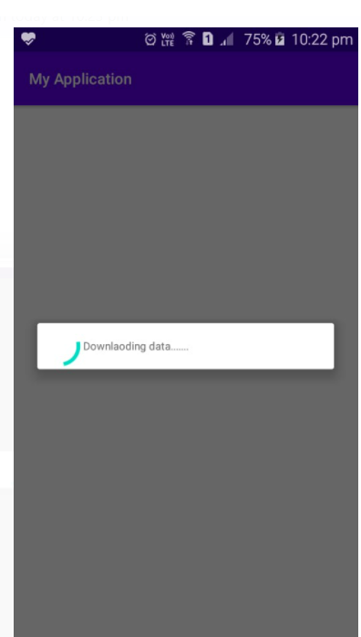

**PRACTICAL:8(A)**

**AIM:**  Explicit Intent

**SOURCE CODE:**

MainActivity.kt:

package com.example.myapplication  
  
import android.content.Intent  
import android.net.Uri  
import androidx.appcompat.app.AppCompatActivity  
import android.os.Bundle  
import android.view.Menu  
import android.view.MenuItem  
import android.widget.Button  
import android.widget.TextView  
import android.widget.Toast  
import androidx.appcompat.app.AlertDialog  
  
class MainActivity : AppCompatActivity() {  
 override fun onCreate(savedInstanceState: Bundle?) {  
 super.onCreate(savedInstanceState)  
 setContentView(R.layout.*activity_main*)  
 val b1= findViewById<Button>(R.id.*redirect*)  
 b1.setOnClickListener**{** val intent = Intent()  
 intent.*action*= Intent.*ACTION_VIEW* intent.*data*= Uri.parse("https://www.google.com/")  
 startActivity(intent)  
 **}** }  
  
}

activityMain.xml:

**OUTPUT:**

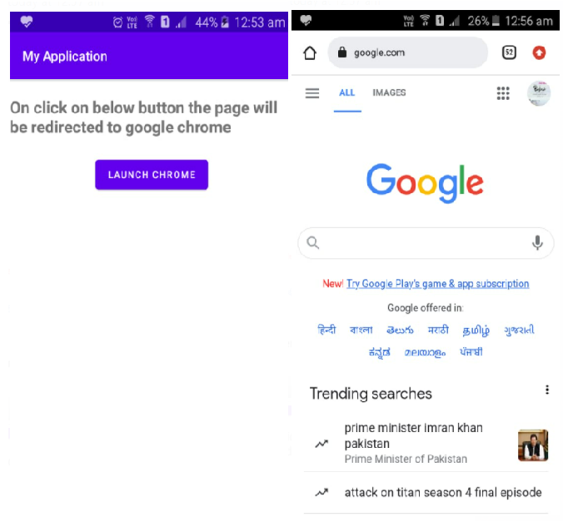

**PRACTICAL:8(B)**

**AIM:**  Permission

**SOURCE CODE:**

**Add one in android mainfiest**

<uses-permission android:name="android.permission.CAMERA"/>

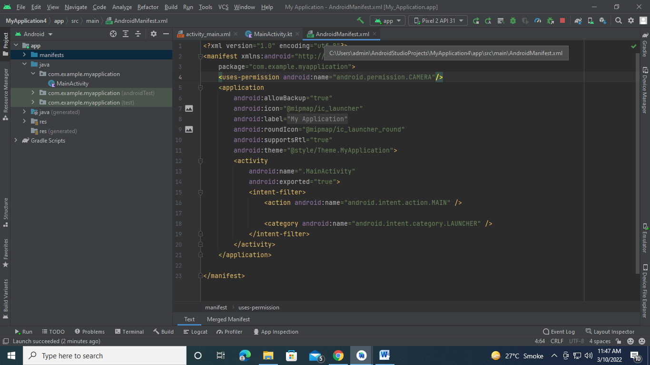

**MainActivity.kt**:

package com.example.myapplication  
  
import android.content.pm.PackageManager  
import androidx.appcompat.app.AppCompatActivity  
import android.os.Bundle  
import android.widget.Toast  
import androidx.core.app.ActivityCompat  
import androidx.core.content.ContextCompat  
  
class MainActivity : AppCompatActivity() {  
 private val CAMERA_REQUEST_CODE = 123;  
  
 override fun onCreate(savedInstanceState: Bundle?) {  
 super.onCreate(savedInstanceState)  
 setContentView(R.layout.*activity_main*)  
 setupPermission()  
 }  
 private fun setupPermission(){  
 val permission = ContextCompat.checkSelfPermission(  
 this, android.Manifest.permission.*CAMERA* )  
 if (permission!= PackageManager.*PERMISSION_GRANTED*){  
 makeRequest()  
 }  
  
 }  
 private fun makeRequest(){  
 ActivityCompat.requestPermissions(  
 this, *arrayOf*(android.Manifest.permission.*CAMERA*),CAMERA_REQUEST_CODE)  
 }  
  
 override fun onRequestPermissionsResult(  
 requestCode: Int,  
 permissions: Array<out String>,  
 grantResults: IntArray  
 ) {  
 super.onRequestPermissionsResult(requestCode, permissions, grantResults)  
 when(requestCode){  
 CAMERA_REQUEST_CODE->{  
 if (grantResults.*isEmpty*()|| grantResults[0]!=PackageManager.*PERMISSION_GRANTED*){  
 Toast.makeText(this,"Permission Denied",Toast.*LENGTH_SHORT*).show()  
 }  
 else{  
 Toast.makeText(this,"Permission Granted ",Toast.*LENGTH_SHORT*).show()  
 }  
 }  
 }  
 }  
}

**OUTPUT:**

